

Event Driven Models

There are 2 models which are widely used

1. Pub/sub model
2. 2) Event stream model

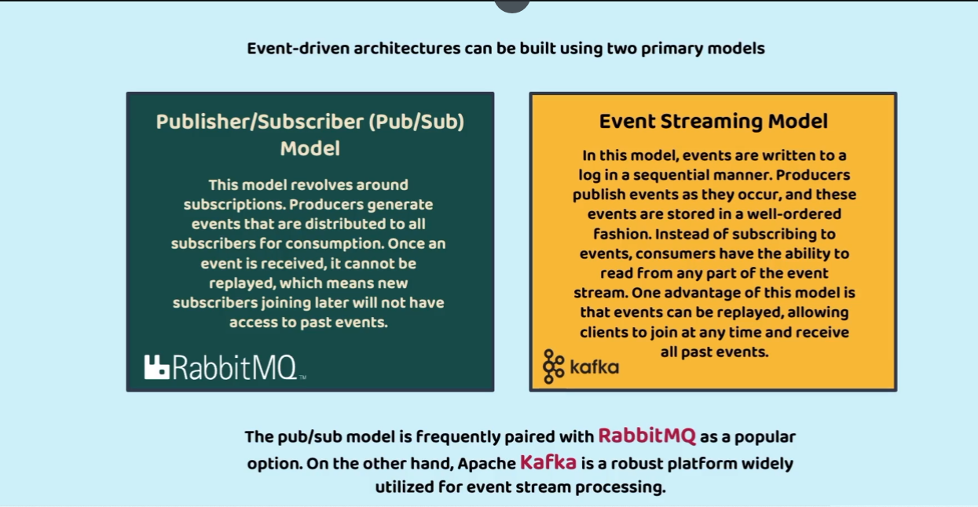

First will go through the Pub/sub model consider a scenario where an account microservice will be creating an account and same will be published to an event broker. The services registered to the event broker receives the notification from broker then process the data and an email messages will be sent to customer. Once message and email are sent then we also have to update in the DB about the communication sent to customer this process is known as reverse asynchronous communication. Here communication between message microservice and accounts microservice is asynchronous

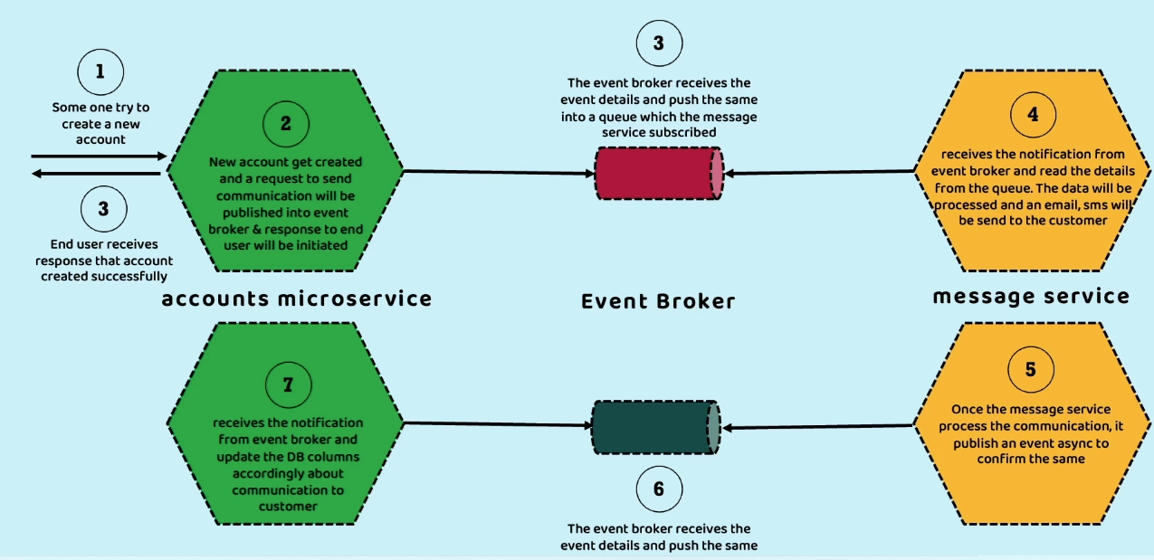

Lets achieve this by RabbitMq it is a light weight message broker it follows the pub sub model where past events are not stored

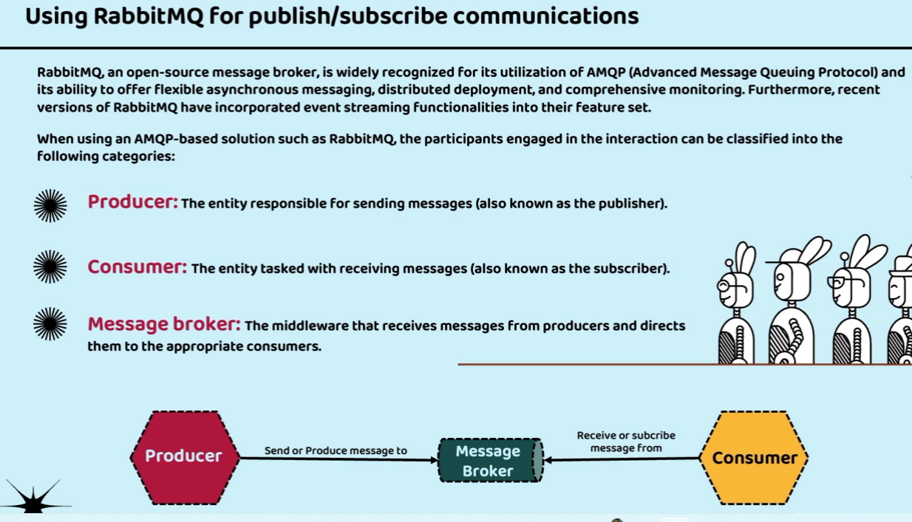

Internally message broker contains exchanges and queues whenever producer produces the events then first it is processed by exchange then depending upon information it then passes it to the queues. And any number of receivers can be subscribed to these queues

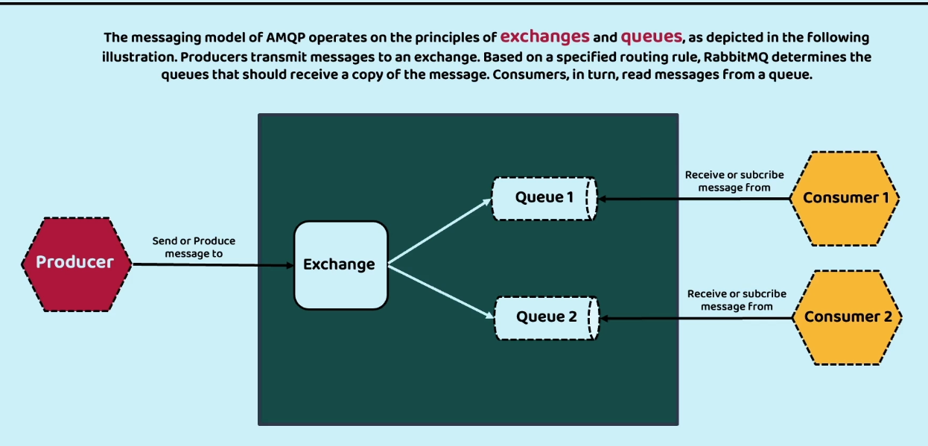

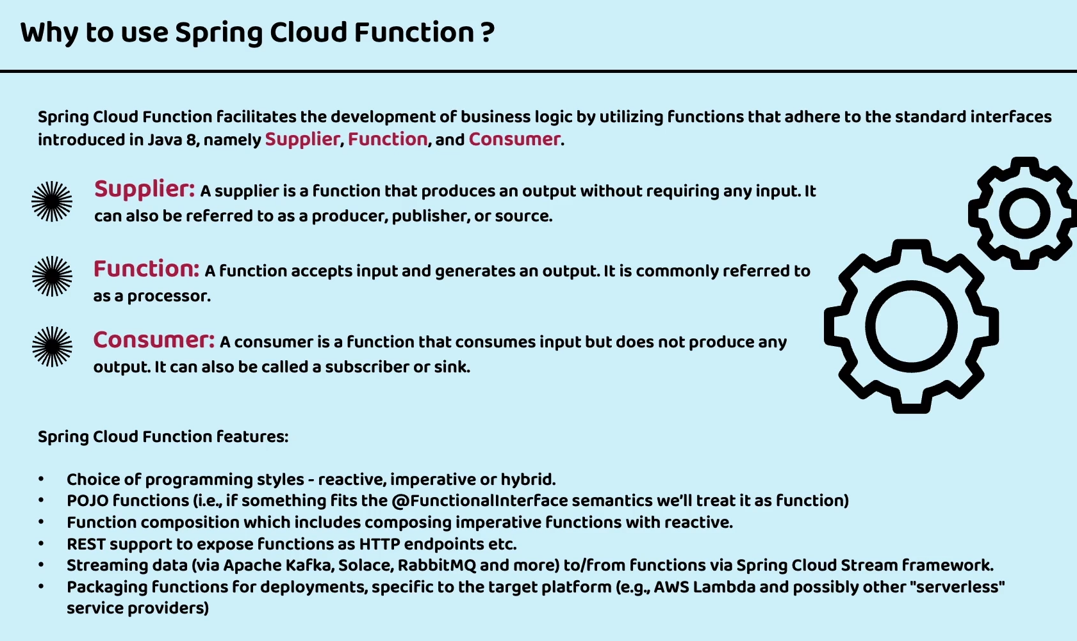

Lets start creating message service app

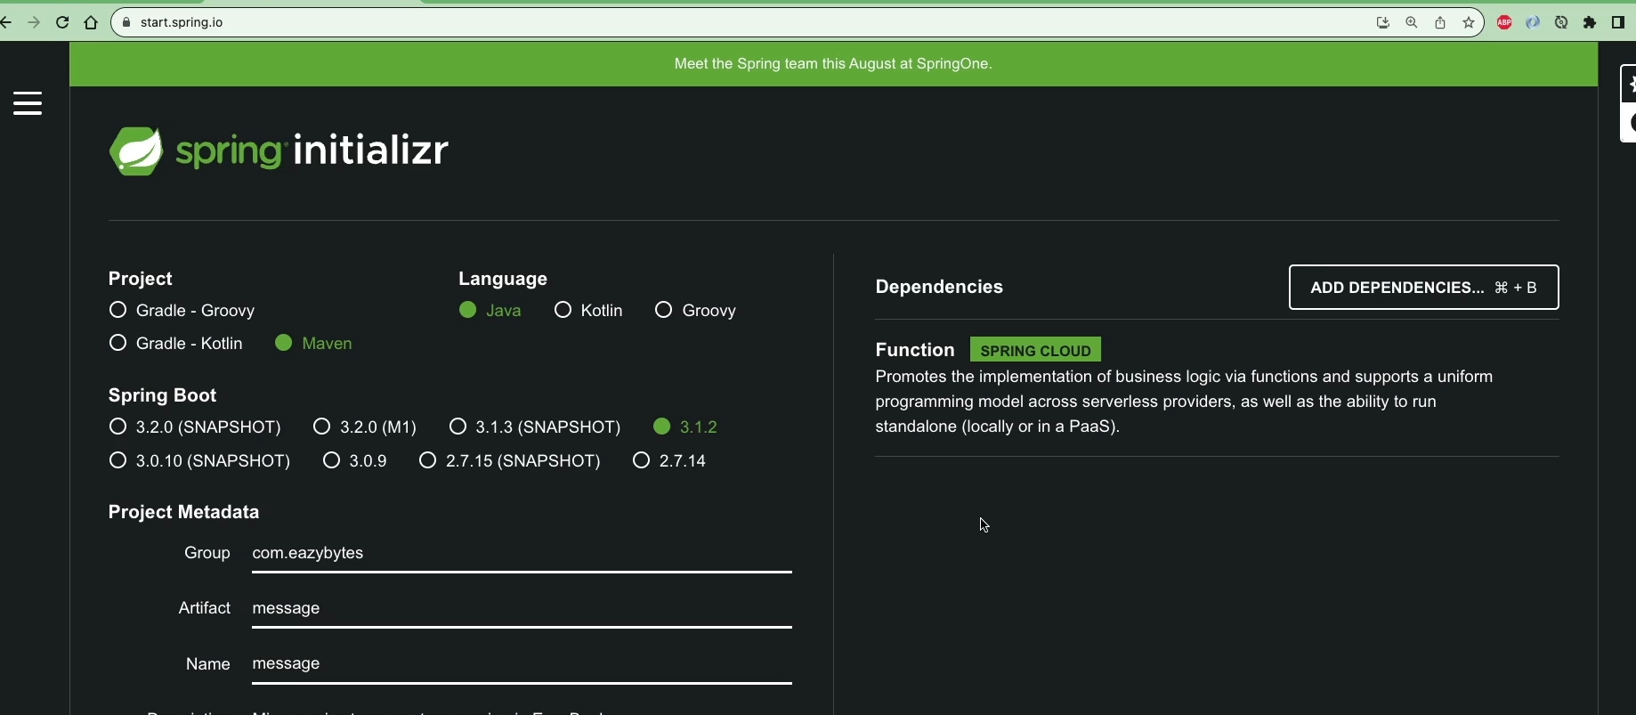

Will create a DTO file of type record this will automatically add getters and setters method which will receive the notification from message broker

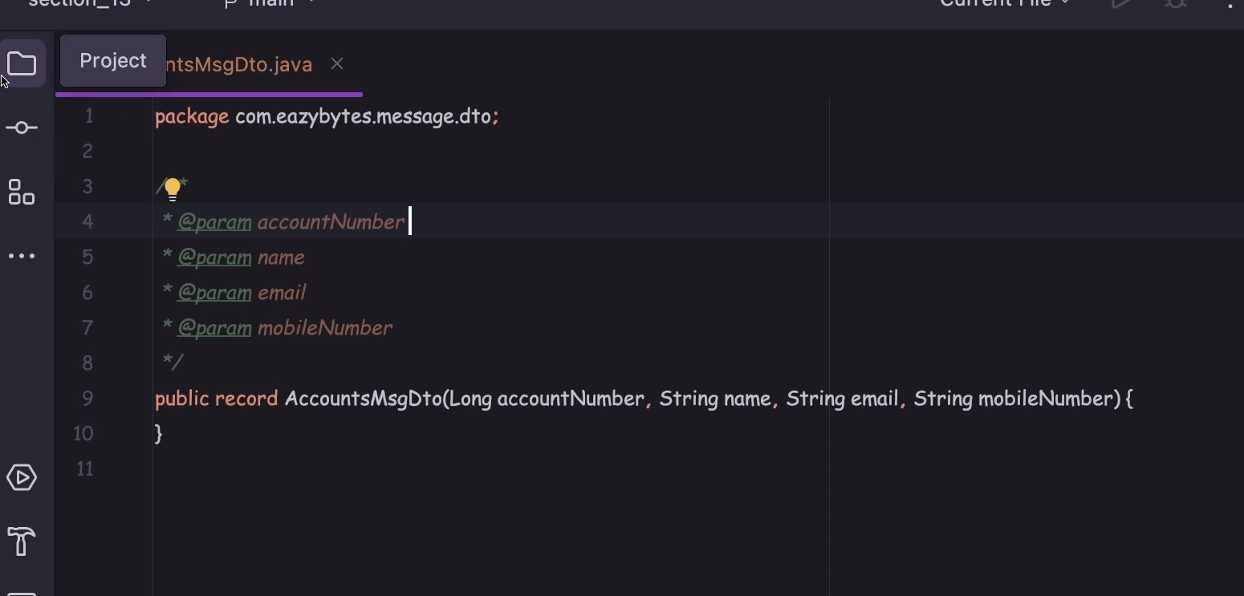

Now will create class with methods that will return a Function interface

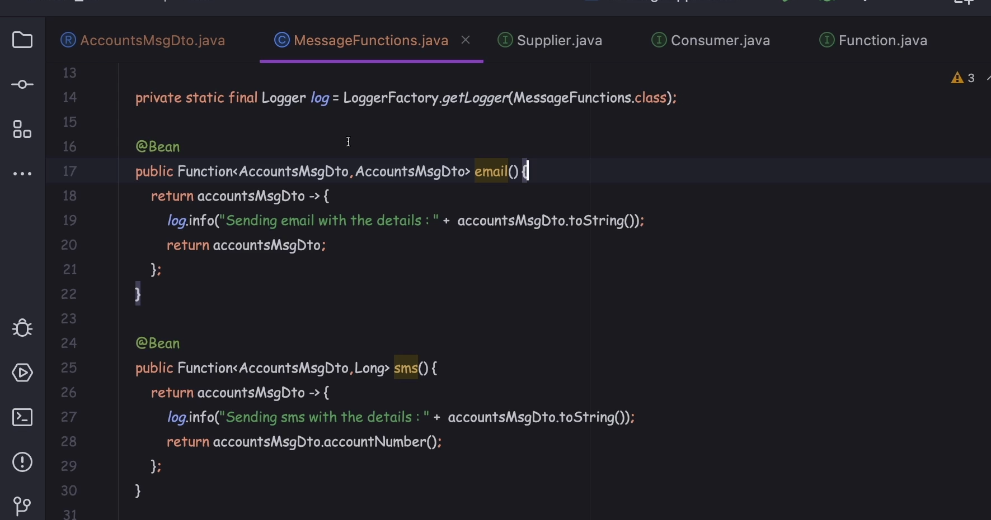

Now to act these methods as API endpoints we need to add one more dependency

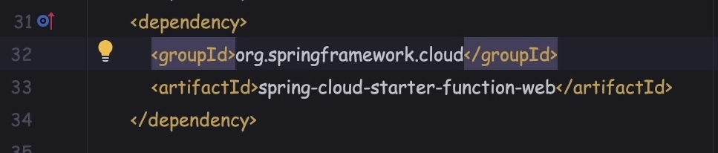

Then start this application and call these methods as normal API call endpoints are same as function name

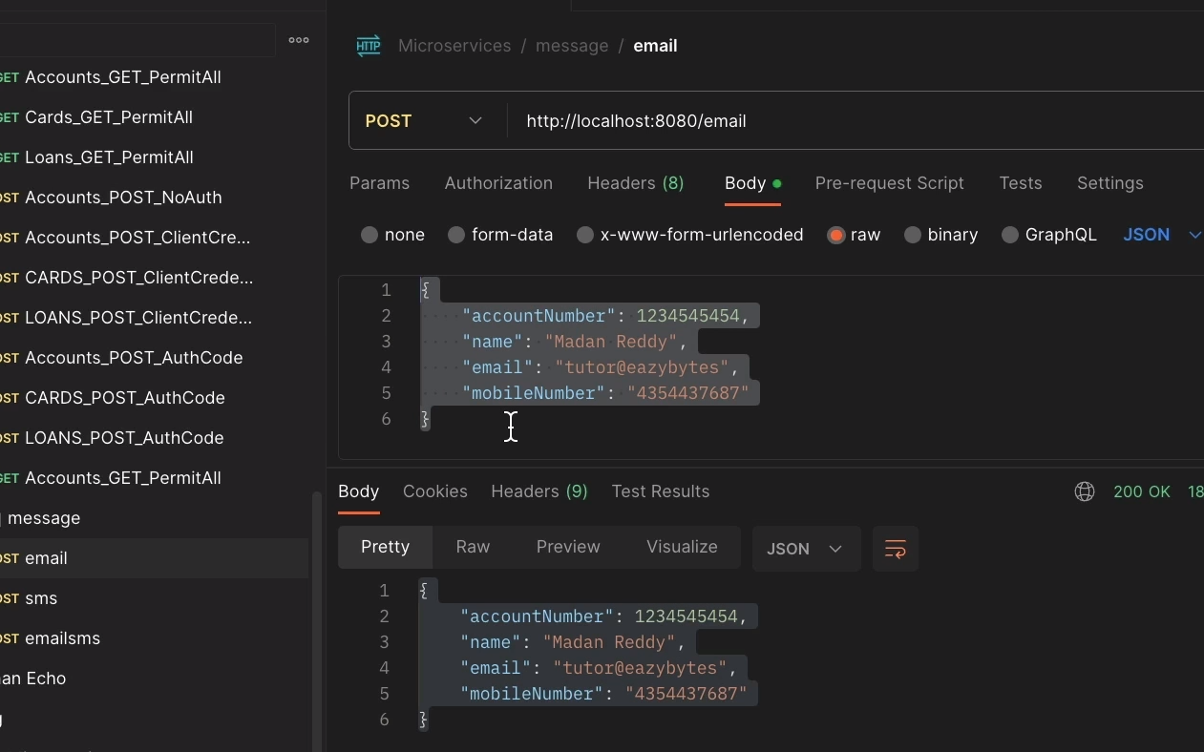

Now to compose email and sms feature as single logical unit so that at a time both the functions are being called. For that we need to configure properties in application.properties file we can combine any number of functions

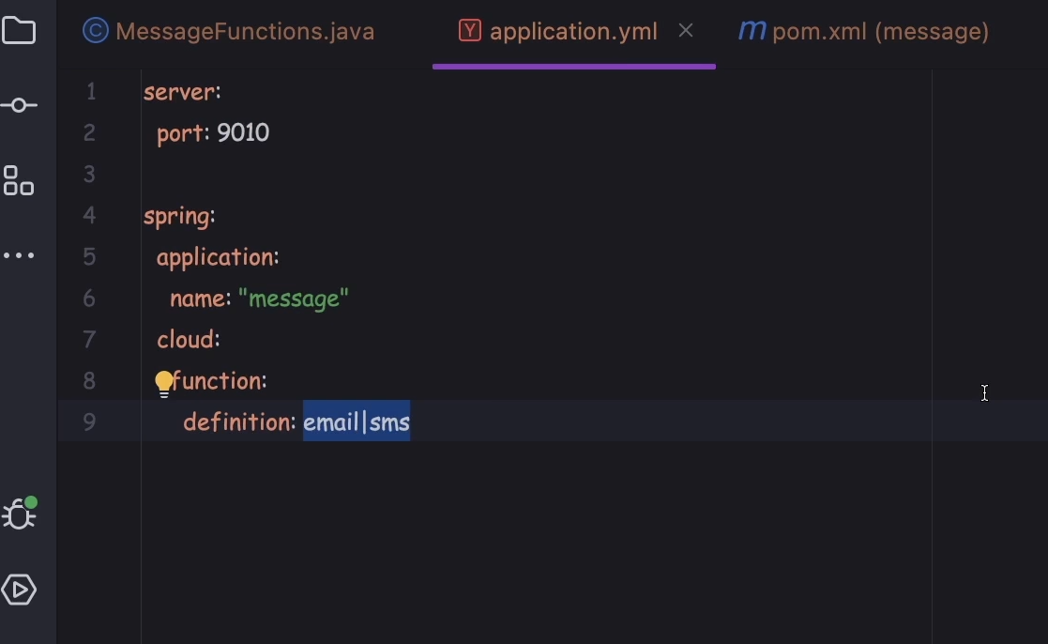

For invoking we need to combine both the function names as below

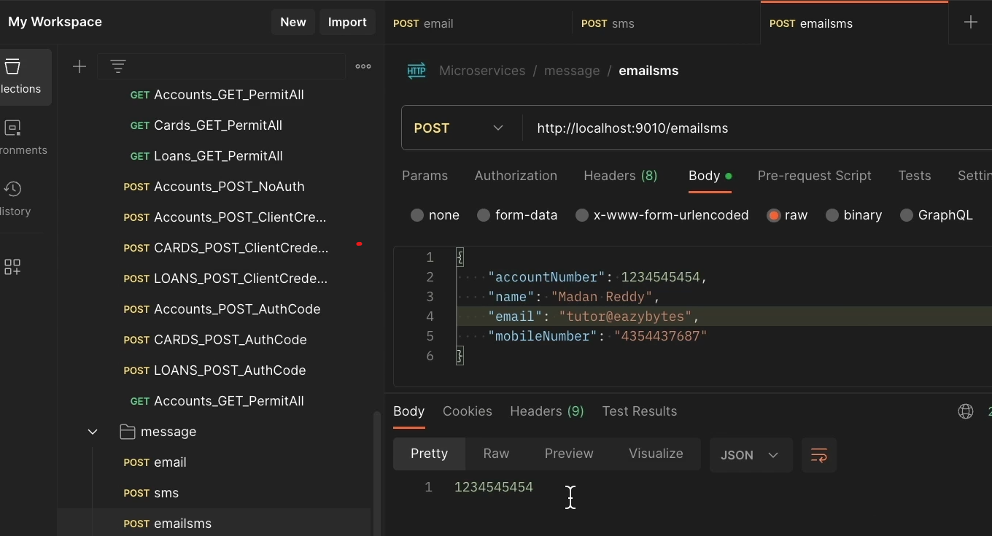

Now to integrate with a message broker like rabbitmq function we need to add spring cloud stream. Reverting API endpoints related changes as we don’t want to expose these API to the outside world hence commenting below dependency

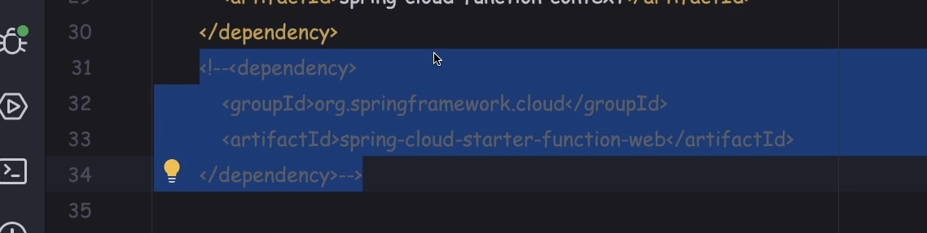

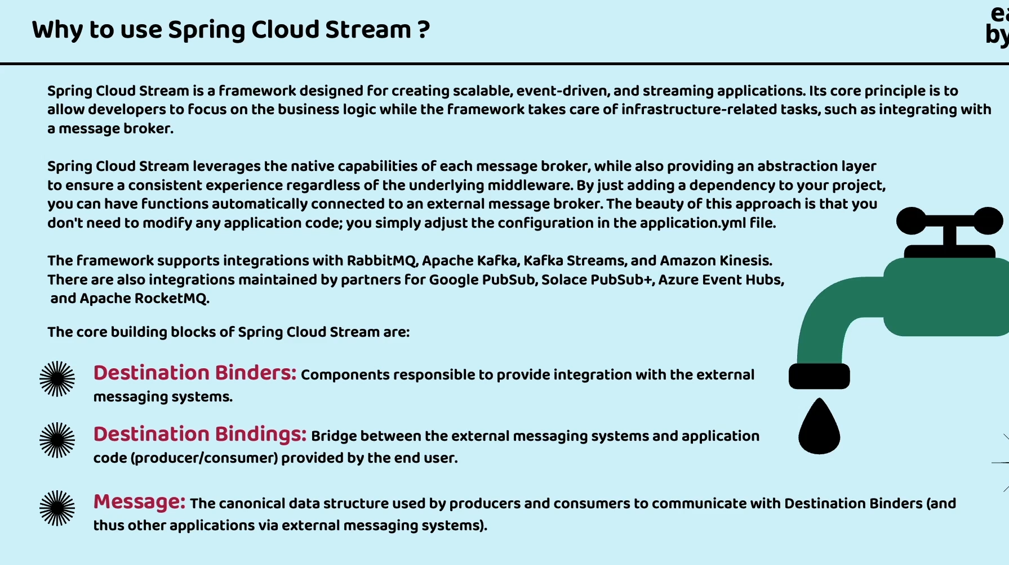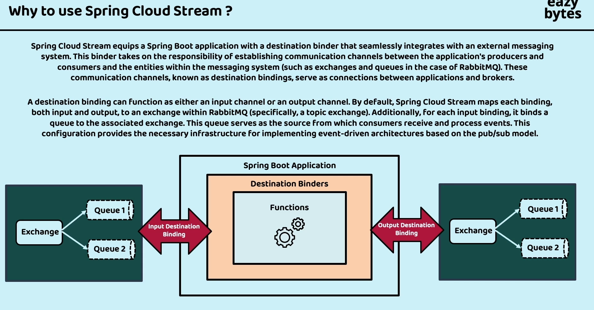

Remove all previously added dependency from message service and add spring cloud stream dependencies so that our message service communicate with the message broker

All dependencies refer here

<https://github.com/eazybytes/microservices/blob/3.2.3/section_13/message/pom.xml>

After this we need to add few more properties in message service which contains the information about the bindings that is message broker establish binding between functions that message service contains and its name is emailsms-in-0, in bcoz it is goint to act as input (receiver) from the message broke. Destination is name given to Queue. Then we need to provide information related rabbitmq

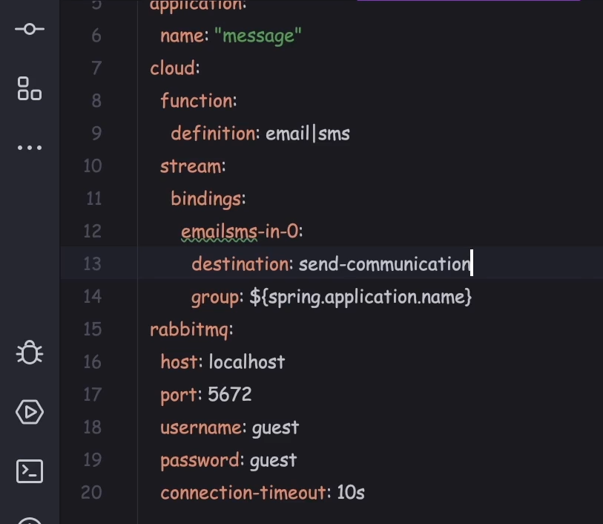

Now change in the service so that it start sending messages to the rabbitmq. 2 dependencies are added in accounts microservices

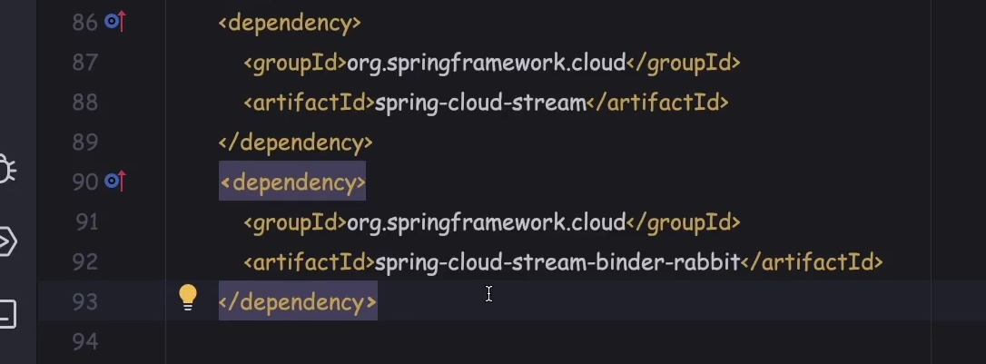

Now create record which is AccountsMsgDto

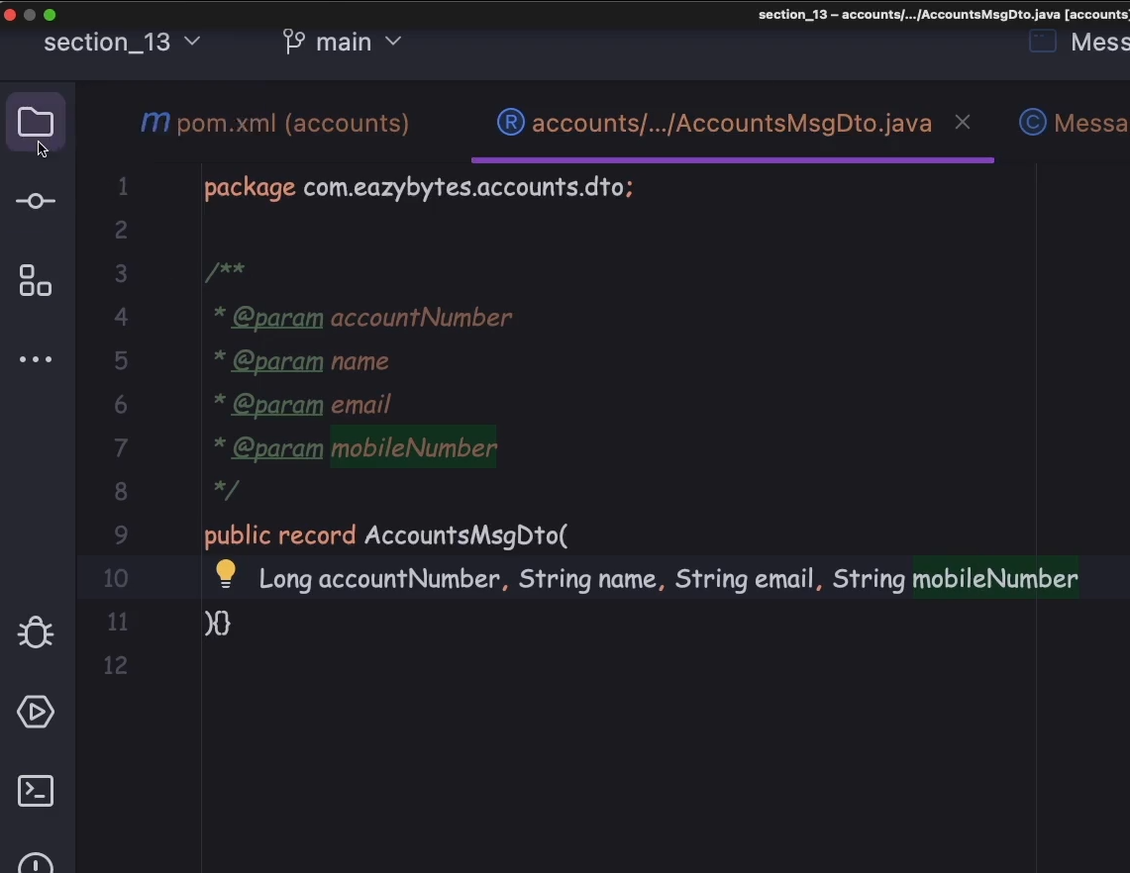

Add the below properties in accounts application properties here bindings name is anyname as there is no functions in it, out bcoz this produces message to the message broker then message exchange name is send-communication same as what is specified in message service then also add rabbitmq related properties

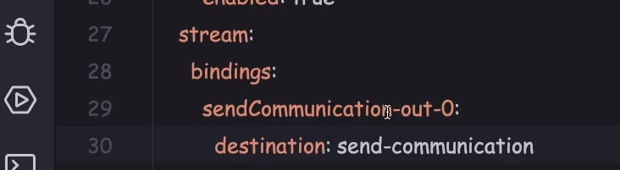

Now in account service AccountServiceCreationImpl autowire a StreamBridge



Now add the below private method that sends msg to message broker to a channel sendCommunication-out-0

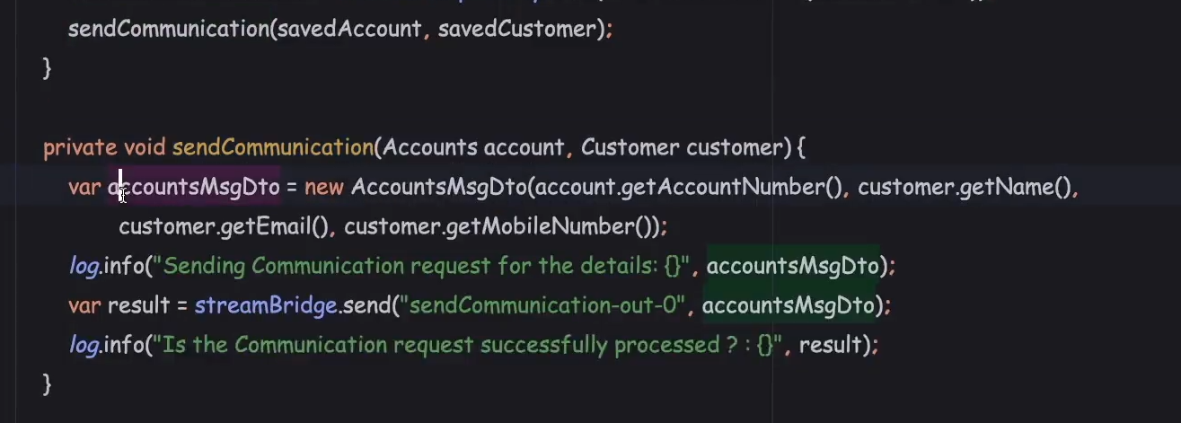

To check running visit 206 topic in udemy

Now lets make changes in message service so that it can send stream back to microservice to perform some last moment operations like updating in accounts service DB about the email/sms being sent to its customers.

So in message service we need to add properties so that it stream out to then message broker as below. Since we have already added input related properties so that it continuously listens to the incoming stream from message broker also we need to output related properties so that it can send stream to the message broker.

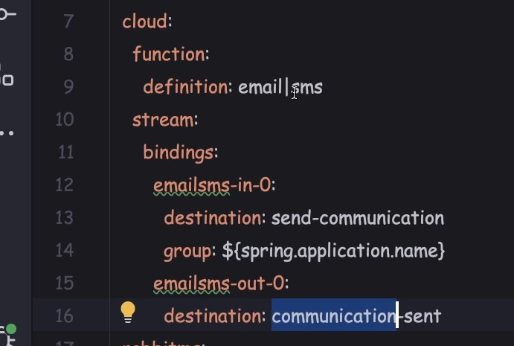

Added emailsms-out-0 which is binding name and uses communication-sent as message queue name. And the output will be the output from last function specified in function:definition:email|sms in our case its sms. Sms will return long data type account number. Now lets create a function in accounts service that listens to message service

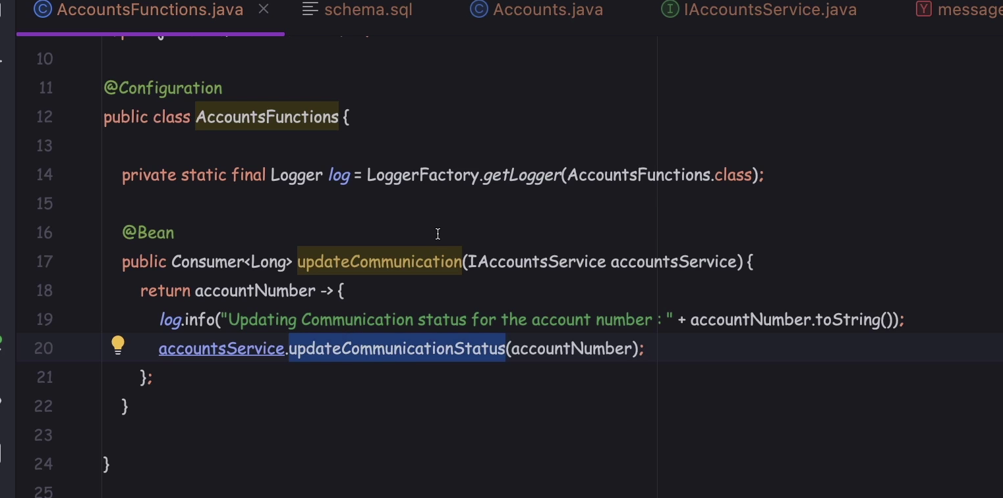

Then we need to add properties related to function:definition which we need to add same function name as above and also add input binding name and destination as queue name

